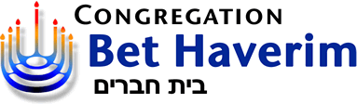  Israel Peace Alternatives  “Pursuit of justice and peace for the preservation and strengthening of a democratic Jewish Israel” | And  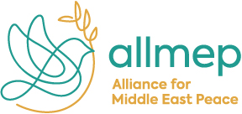 | And  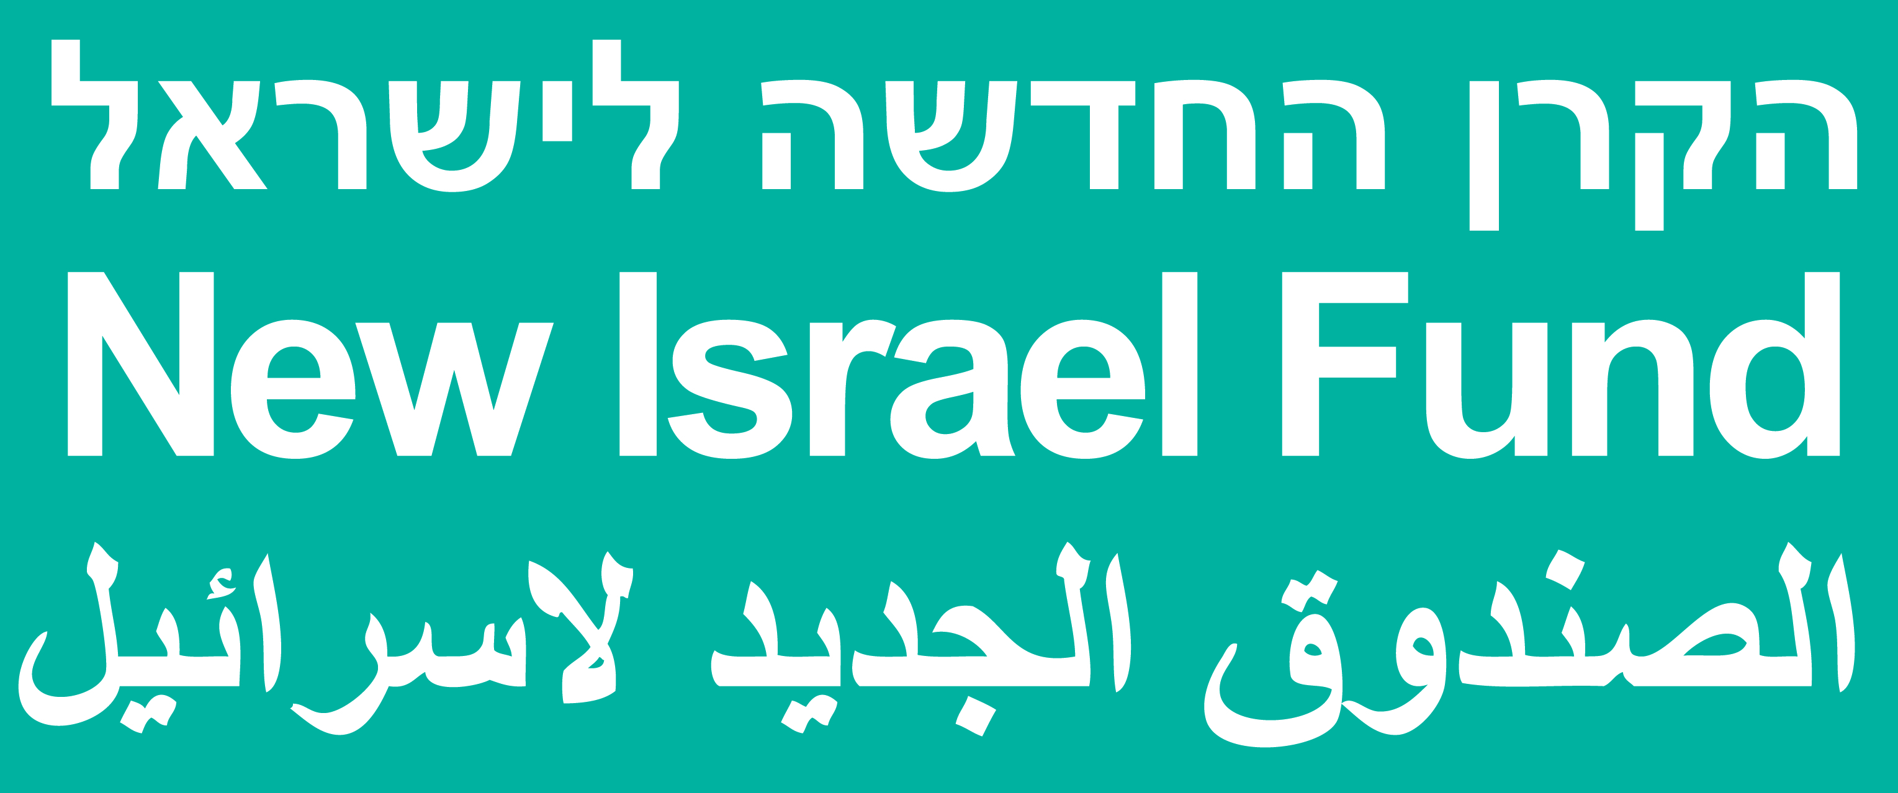

And Rabbi Greg Wolfe
present
AVI MYERSTEIN  ALLMEP Founder  And President | and KEVIN RACHLIN  ALLMEP US Director
 | 

Speaking on

The International Fund for Israeli-Palestinian Peace:
“Give Peace a Chance (and Some Funding)”

Tuesday, May 11, 2021, 2:00 pm Pacific via zoom
Register in advance for this meeting:
https://us02web.zoom.us/meeting/register/tZModOmgrTMjH9UuVDGie59aFPBAj5NAbhaK
After registering, you will receive a confirmation email containing information about joining the meeting.

The Nita M. Lowey Middle East Partnership for Peace Act, historic legislation delivering unprecedented levels of funding for peacebuilding in Israel and Palestine, has now passed into law in the United States. The law provides $250 million over five years to expand peace and reconciliation programs in the region, as well as to support projects to bolstering the Palestinian economy. This legislation is the result of over a decade of advocacy by the Alliance for Middle East Peace (ALLMEP) toward the creation of an International Fund for Israeli-Palestinian Peace.
In 2003, Avi Myerstein led dozens of NGOs to join forces in a single umbrella coalition, creating ALLMEP. He led a team of volunteer attorneys to develop proposals and advocacy strategies to significantly expand resources and scale up Israeli-Palestinian people-to-people activities. So far, these efforts have resulted in over $110 million in US and international funding. He also first proposed and launched the initiative to take the next leap in growth by creating an international fund to dramatically invest in grassroots P2P efforts.
Kevin Rachlin brings over a decade of experience in U.S.-focused advocacy and non-profit leadership to ALLMEP. Prior to this, Kevin served as the Director of Public Policy and Government Affairs at InterAction, the largest alliance of nongovernmental international organizations. In this role, Kevin led InterAction’s advocacy efforts to the U.S. Government, strengthening the voice and role of civil society in global development and international relief efforts. Kevin also served for nearly 7 years at J Street in multiple roles, including Deputy Director of Government Affairs and Deputy Chief of Staff. Kevin has also served as the Director of Government Affairs for the Basic Education Coalition, working with leading NGO organizations to elevate global education within the U.S. Government.

This event is free and open to the public. For more information visit bethaverim.org; allmep.org; nif.org.

The views expressed by this program, the speaker, or the speaker's sponsoring organization are not necessarily the views of Congregation Bet Haverim. Our congregation is committed to honoring the diversity of thoughts and opinions within our community.

